Programme Code: DT9231
Module Code: DATA MATH 9102
CRN 32040

TECHNOLOGICAL UNIVERSITY DUBLIN
KEVIN STREET CAMPUS

_____________

Postgraduate Certificate in Data Science

Year 1
______________

SEMESTER 1 EXAMINATIONS 2019/20
______________

Probability and Statistical Inference

Dr. Bojan Božić
Dr. Deirdre Lillis
Dr. Ignacio Castiñeiras

Two Hours

Instructions to candidates.

Answer question set 1 and one other question set.

All questions carry equal marks.

SOLUTIONS

QUESTION SET 1:
- What is a confounding variable?
(2 points)
A variable that affects the outcome being measured as well as or instead of the independent variable.
- If my null hypothesis is ‘Dutch people do not differ from English people in height’, what is my alternative hypothesis?
(2 points)
All of the above are plausible alternative hypotheses.
- If the scores on a test have a mean of 26 and a standard deviation of 4, what is the z‐ for a score of 18?
(3 points)
–2
- What is p the probability of?
(3 points)
p is the probability of observing results as extreme as (or more extreme than) observed, if the null hypothesis (H0) is true.
- What is a type I error?
(2 points)
We conclude that there is an effect in the population when in fact there is not.
- What is the relationship between the sum of squared errors (SS), the sample size (n) and the variance (s2)?
(3 points)
s2=SS/(n–1)
- Based on the following chart, what was the interquartile range of sperm count for ‘No soya meals’ (approximately).
(3 points)
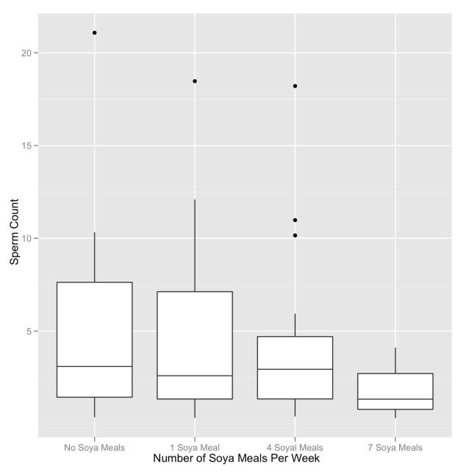
5.5

- Which measure of central tendency is least affected by outliers?
(2 points)
The median.
- The assumption of homogeneity of variance is met when?
(2 points)
Variances in different groups are approximately equal.
- How much variance has been explained by a correlation of .9?
(2 points)
81%
- The relationship between two variables controlling for the effect that a third variable has on one of those variables can be expressed using a:
(3 points)
Semi‐partial correlation.
- What is R2?
(3 points)
The proportion of variance in the outcome accounted for by the predictor variable or variables.
- For which regression assumption does the Durbin–Watson statistic test?
(3 points)
Independence of errors.
14. A psychologist was interested in whether there was a gender difference in the use of email. She hypothesized that because women are generally better communicators than men, they would spend longer using email than their male counterparts. To test this hypothesis, the researcher sat by the email computers in her research methods laboratory and when someone started using email, she noted whether they were male or female and then timed how long they spent using email (in minutes). What should she report?
Welch Two Sample t-test
data: Time Using Email
t = -1.895, df = 7.177, p-value (two-tailed) = 0.099
alternative hypothesis: true difference in means is not equal to 0
95 percent confidence interval:
-60.52295 6.52295
(5 points)
Females spent significantly longer using email than males, t(7.18) = –1.90, p < .05.
- What is an independent t‐test used for?
(4 points)
Differences between means of groups containing different people when the data are normally distributed, have equal variances and data are at least interval.
- A researcher measured the same group of people’s physiological reactions while watching horror films and compared them to when watching erotic films. The resulting data were normally distributed. What test should be used to analyse the data?
(4 points)
Dependent (related) t‐test.
- A researcher measured people’s physiological reactions while watching horror films and compared them to when watching erotic films and a documentary about wildlife. Different people viewed each type of film. The resulting data were normally distributed and the variances across groups were similar. What test should be used to analyse the data?
(4 points)
Independent analysis of variance.

QUESTION SET 2:

- A psychologist was looking at the effects of an intervention on depression levels. Three groups were used: waiting list control, treatment and post treatment (a group who had had the treatment 6 months before). The change in depression levels over the time of the treatment was recorded (although bear in mind only the treatment group actually got any treatment during this time). The R output is below. Based on this output, what should the researcher conclude?
(5 points)
Levene's Test for Homogeneity of Variance (center = "median")
Df F value Pr(>F)
group 2 4.246 0.020
45
Df Sum Sq Mean Sq F value Pr(>F)
group 2 529.437 264.719 5.110 .010
Residuals 45 2331.135 51.803
One-way analysis of means (not assuming equal variances)
data: tumour and usage
F = 4.345, num df = 2.00, denom df = 26.436, p-value = .023

The treatment groups had a significant effect on the change in depression levels, F(2, 26.44) = 4.35.
- What kind of trend does the following graph show?
(2 points)
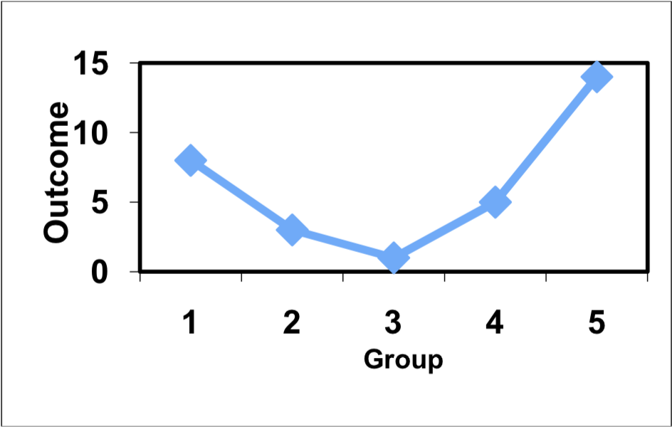

Quadratic.

- The student welfare office was interested in trying to enhance students’ exam performance by investigating the effects of various interventions. They took five groups of students before their Research Methods II (RMII) exams and gave them one of five interventions: a control group just sat in a room contemplating the task ahead; the second group had a yoga class to relax them; the third was told they would get monetary rewards contingent upon the grade they received in the exam; the fourth was given beta‐blockers to calm their nerves; and the fifth was encouraged to sit around winding each other up about how much revision they had/hadn’t done (a bit like what usually happens). The final percentage obtained in the exam was the dependent variable. The student welfare office made four predictions: (1) all interventions should be different than the control; (2) yoga, bribery and beta‐blockers should lead to higher exam scores than panic; (3) yoga and bribery should have different effects than the beta‐blocker drugs; and (4) yoga and bribery should also differ. Which of the following planned contrasts (with the appropriate group codings) are correct to test these hypotheses?
- points)

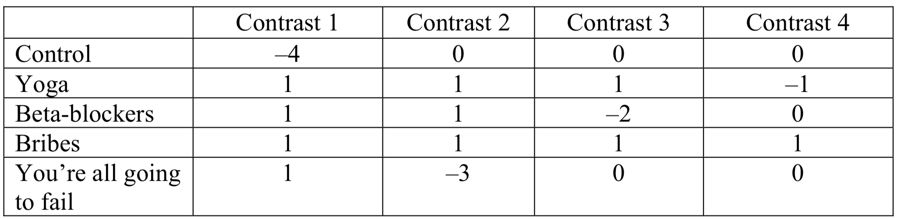

- A music teacher had noticed that some students went to pieces during exams. He wanted to test whether this performance anxiety was different for people playing different instruments. He took groups of guitarists, drummers and pianists (variable = Instru) and measured their anxiety (variable = Anxiety) during the exam. He also noted the grade of exam they were taking (in the UK, musical instrument exams are known as ‘grades’ and range from 1 to 8). He wanted to see whether the type of instrument played affected performance anxiety when controlling for the grade of the exam. What analysis should he use?
(3 points)
Analysis of covariance.
- The next part of the R output for the example in the previous question is given below. Which of the following statements best reflects what the effect of INSTRU in the table tells us?
(10 points)
Response: ANXIETY
Sum Sq Df F value
Pr(>F)
.000 ***
.023 *
.000 ***
(Intercept) 32903.788 1
GRADE 907.833 1
INSTRU 6351.708 2
Residuals 9325.228 56
197.594
5.452
19.072

The type of instrument played in the exam had a significant effect on the level of anxiety experienced even after the effect of the grade of the exam had been accounted for.
- A psychologist was interested in the effects of different fear information in children’s beliefs about an animal. Three groups of children were shown a picture of an animal that they had never seen before (a quoll). Then one group was told a negative story (in which the quoll is described as a vicious, disease‐ridden, bundle of nastiness that eats children’s brains), one group a positive story (in which the quoll is described as a harmless, docile creature that likes nothing more than to be stroked), and a final group weren’t told a story at all. After the story children rated how scared they would be if they met a quoll, on a scale ranging from 1 (not at all scared) to 5 (very scared indeed). To control for the natural anxiousness of each child, a questionnaire measure of trait anxiety was given to the children and used in the analysis. The (edited) R output is below. The next two questions relate to this output.
(20 points)
Response: Fear of Animal
Sum Sq Df F value Pr(>F)
(Intercept). 96.249 1 109.141 .000 ***
Natural Fear Level 4.924 1 5.579 .022*
Type of Information. 13.567 2 7.685. .001 **
Residuals. 49.426 56

: Type of Information
: Positive
mean SE.mean
2.594 .219
------------------------
: Negative
mean SE.mean
3.658 .211
------------------------
: None
mean SE.mean
2.697 .215
-------------------------

Simultaneous Confidence Intervals
Multiple Comparisons of Means: Tukey Contrasts
Fit: aov(formula = libido ~ partnerLibido + dose, data = viagraData)
Quantile = 2.4856
95% family-wise confidence level
Linear Hypotheses:
Estimate lwr upr
Positive - None == 0 -0.103 -0.880 .675
Negative - None == 0 0.961 0.225 1.697
Negative - Positive == 0 1.064 0.306 1.823

What analysis has been used?
Analysis of covariance.
What does the effect of Natural Fear Level in the table tell us?
The child’s natural level of fear had a significant relationship with their fear beliefs about the animals.

QUESTION SET 3:
- A nutritionist conducted an experiment on memory for dreams. She wanted to test whether it really was true that eating cheese before going to bed made you have bad dreams. Over three nights, the nutritionist fed people different foods before bed. One night they had nothing to eat, a second night they had a big plate of cheese, and the third night they had another dairy product, milk, before bed. All people were given all foods at some point over the three nights. The nutritionist measured heart rate during dreams as an index of distress. How should these data be analysed?

